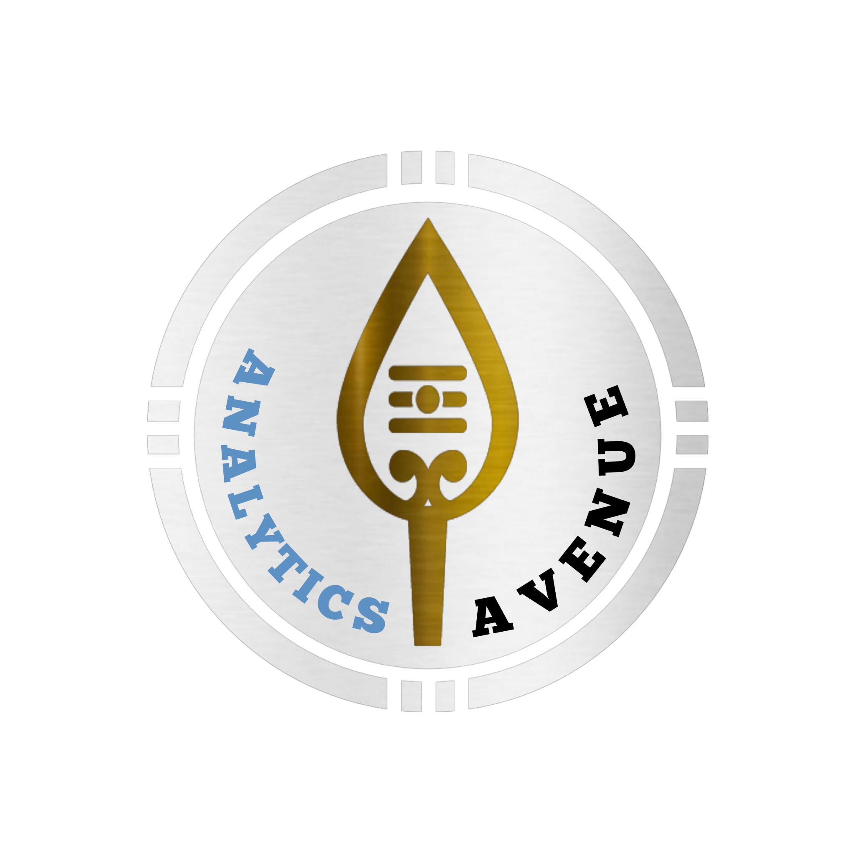

**Lets Bridge the Gap between**

**Self paced learning and Industrial expectations**

|  |
| --- |
| **Candidate Target sheet**  Name: J Maran Jeys  Designation: Reimbursement Specialist  D.O.J: 28/0502023  To share among your friends  <https://www.instagram.com/p/Crizh16or2n/>  I have found a social media influencer who serve as a data scientist for 5_ years in a reputed analytical organisation at Chennai. He has addressed 1500+ Engineering Students and helped 100+ professionals in their career transition Kindly look into his social media accounts for better understanding Insta:<https://www.instagram.com/subu_datascientist/> Linkedin:<https://www.linkedin.com/in/subramani-arumugam-14100b169/>  Task given :   * Should create healthcare oriented / insurance data set and have to create dashboard that shows your insights and should talk about domain and data set before **Aug 30th**. * Whatever the task is given that we have to update in task sheet. * Book mark all the given access in the chrome.   Update this file on Github by the name of self-candidate info |

|  |
| --- |
|  |